**Questions taken from** **(Video)**[***Data Normalization Intro***](https://youtu.be/0dytZ5iFlvg)**|**[**PowerPoint**](https://tschultz.azurewebsites.net/courses/AIST6410/content/DataNormalizationIntro.pptx) **especially the digression on keys.**

The following relation is an extract from a restaurant point-of-sale (POS) system. The system assigns a globally unique id (GUID) to every transaction processed. CheckID comes from the pre-printed check number on the ticket used by the server for the order; these pre-printed tickets are guaranteed to be unique within the restaurant. RegisterID is which register was used for checkout and the date and time of the checkout – to the minute – are recorded in CheckoutDT; assume no two checkouts can occur at the same register in the same minute. PayType and PayTotal are, respectively, how the check was paid and what the total payment was; assume there is no splitting of a check among multiple payments.

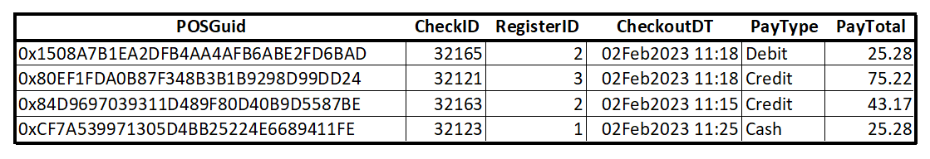

When answering the questions below use the format [attribute, attribute, …, attribute] to identify keys.

**How many keys in general (including the empty or null key) are there in this relation?**

**Identity two multi-keys for this relation.**

**Identify two super keys which are not also candidate keys for this relation.**

**Identify all candidate keys for this relation.**

**What would you recommend as primary key for this relation? Why?**

**If splitting or multiple payments were to be allowed for a ticket total (e.g., suppose the second payment above consisted of a 35.10 Credit payment and a 30.12 Cash payment), what changes would you suggest to the relation above?**